**INDEX**

|  |  |  |  |  |  |
| --- | --- | --- | --- | --- | --- |
| **Sl. No** | **Date** | **Name of Experiment** | **Page No.** | **Marks** | **Signature of the faculty** |
|  |  |  |  |  |  |
|  |  |  |  |  |  |
|  |  |  |  |  |  |
|  |  |  |  |  |  |
|  |  |  |  |  |  |
|  |  |  |  |  |  |
|  |  |  |  |  |  |
|  |  |  |  |  |  |
|  |  |  |  |  |  |
|  |  |  |  |  |  |

**INDEX**

|  |  |  |  |  |  |
| --- | --- | --- | --- | --- | --- |
| **Sl. No** | **Date** | **Name of Experiment** | **Page No.** | **Marks** | **Signature of the faculty** |
|  |  |  |  |  |  |
|  |  |  |  |  |  |
|  |  |  |  |  |  |
|  |  |  |  |  |  |
|  |  |  |  |  |  |
|  |  |  |  |  |  |
|  |  |  |  |  |  |
|  |  |  |  |  |  |
|  |  |  |  |  |  |
|  |  |  |  |  |  |

|  |  |
| --- | --- |
| **EX:NO: 1.1** | **WRITE  CONDITIONAL AND LOOPING STATEMENTS IN PYTHON** |
| **DATE:** |
| **IMPLEMENTATION OF A PYTHON PROGRAM THAT CHECKS IF THE GIVEN INTEGER IS POSITIVE OR NEGATIVE OR ZERO.** | |

**AIM:**

To write a Python program prints whether the given integer is positive, negative, or zero.

**PSEUDO CODE:**

START

    PROMPT user to enter a number and store it in num

    IF num is greater than 0:

        PRINT "The number is positive."

    ELSE IF num is less than 0:

        PRINT "The number is negative."

    ELSE:

        PRINT "The number is zero."

END

**FLOW CHART:**

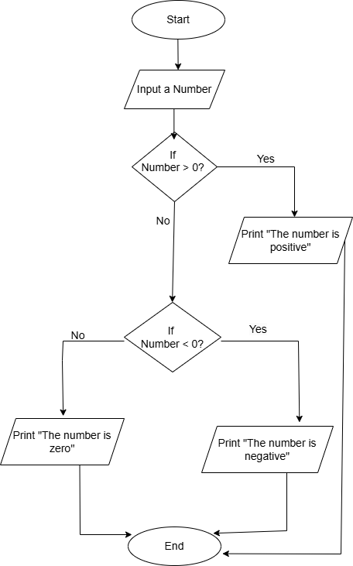

**SOURCE CODE:**

num = int(input("Enter a number: "))

if num > 0:

    print("The number is positive.")

elif num < 0:

    print("The number is negative.")

else:

print("The number is zero.")

**OUTPUT:**

Enter a number: 10

The number is positive.

**RESULT:**

Thus the python program to print whether the given integer is positive, negative, or zero has been successfully executed and the output was verified.

|  |  |
| --- | --- |
| **EX:NO: 1.2** | **WRITE  CONDITIONAL AND LOOPING STATEMENTS IN PYTHON** |
| **DATE:** |
| **WRITE A PROGRAM TO CHECK WHETHER THE YEAR IS LEAP YEAR OR NOT** | |

**AIM:**

To Implement a python program that checks whether a given year is a leap year or not.

**PSEUDO CODE:**

START

    PROMPT user to enter a year and store it in year

    IF (year is divisible by 4 AND year is NOT divisible by 100) OR (year is divisible by 400):

        PRINT "year is a leap year."

    ELSE:

        PRINT "year is not a leap year."

END

**FLOW CHART:**

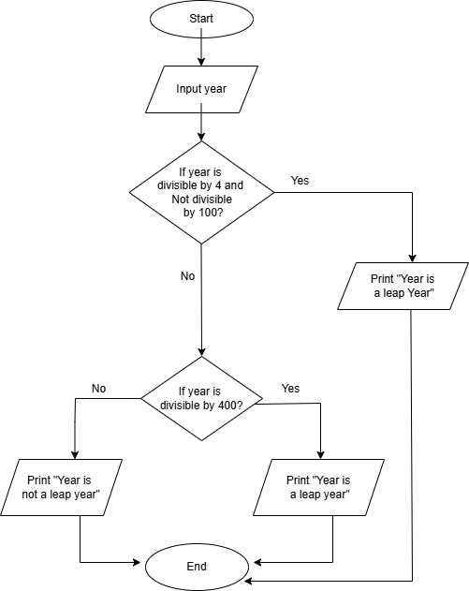

**SOURCE CODE:**

year = int(input("Enter a year: "))

if (year % 4 == 0 and year % 100 != 0) or (year % 400 == 0):

    print(f"{year} is a leap year.")

else:

    print(f"{year} is not a leap year.")

**OUTPUT:**

Enter a year: 2024

2024 is a leap year.

**RESULT:**

Thus the python program that checks whether a given year is a leap year or not has been successfully executed and the output was verified.

|  |  |
| --- | --- |
| **EX:NO: 1.3** | **WRITE  CONDITIONAL AND LOOPING STATEMENTS IN PYTHON** |
| **DATE:** |
| **WRITE A PYTHON PROGRAM TO FIND THE SQUARE ROOT OF A NUMBER** | |

**AIM:**

 To write a Python program to print the square root of the given number.

**PSEUDO CODE:**

START

    PROMPT user to input a number and store it in variable num

    SET i to 1

    WHILE True:

        IF i *i  greater than or equals to  num:

            SET sqrt_num to i

            BREAK the loop

        INCREMENT i by 1

    IF i*i == num:

sqr_num = i

   ELSE:

           sqr_num = i-1

   PRINT "The square root of", num, "is", sqrt_num

END

**FLOW CHART:**

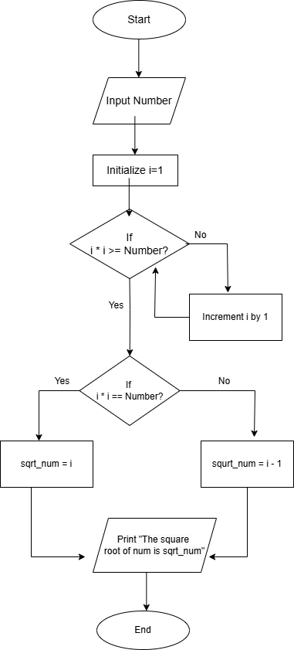

**SOURCE CODE:**

num = int(input("Enter the number: "))

i = 1

while True:

    if i*i >= num:

        break

    i += 1

if i*i == num:

    sqrt_num=i

else:

    sqrt_num=i-1

print(f"The square root of {num} is {sqrt_num}")

**OUTPUT:**

Enter the number: 16

The square root of 16 is 4

**RESULT:**

Thus the python program to print the square root of the given number has been successfully executed and the output was verified.

|  |  |
| --- | --- |
| **EX:NO: 1.4** | **WRITE  CONDITIONAL AND LOOPING STATEMENTS IN PYTHON** |
| **DATE:** |
| **IMPLEMENTATION OF A PYTHON PROGRAM TO PRINT THE GCD OF THE GIVEN NUMBERS.** | |

**AIM:**

 To write a Python program to print the GCD of the given numbers.

**PSEUDO CODE:**

START

    PROMPT user to enter num1 and store it in num1

    PROMPT user to enter num2 and store it in num2

    SET temp to the smaller of num1 and num2

    WHILE True:

        IF num1 is divisible by temp AND num2 is divisible by temp:

            SET gcd_result to temp

            BREAK the loop

        DECREMENT temp by 1

    PRINT "The GCD of", num1, "and", num2, "is", gcd_result

END

**FLOW CHART:**

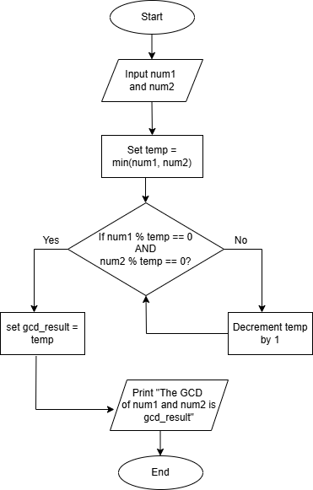

**SOURCE CODE:**

num1 = int(input("Enter num1: "))

num2 = int(input("Enter num2: "))

temp = min(num1, num2)

while True:

    if num1 % temp == 0 and num2 % temp == 0:

        gcd_result = temp

        break

    temp -= 1

print(f"The GCD of {num1} and {num2} is {gcd_result}")

**OUTPUT:**

Enter num1: 15

Enter num2: 20

The GCD of 15 and 20 is 5

**RESULT:**

Thus the python program to print the GCD of the given number has been successfully executed and the output was verified.

|  |  |
| --- | --- |
| **EX:NO: 1.5** | **WRITE  CONDITIONAL AND LOOPING STATEMENTS IN PYTHON** |
| **DATE:** |
| **IMPLEMENTATION OF PYTHON PROGRAM TO PRINT THE LCM OF THE GIVEN NUMBERS.** | |

**AIM:**

 To write a Python program to print the LCM of the given numbers

**PSEUDO CODE:**

START

    PROMPT user to enter num1 and store it in num1

    PROMPT user to enter num2 and store it in num2

    SET temp to the larger of num1 and num2

    WHILE True:

        IF num1 is divisible by temp AND num2 is divisible by temp:

            SET lcm_result to temp

            BREAK the loop

        INCREMENT temp by 1

    PRINT "The LCM of", num1, "and", num2, "is", lcm_result

END

**FLOW CHART:**

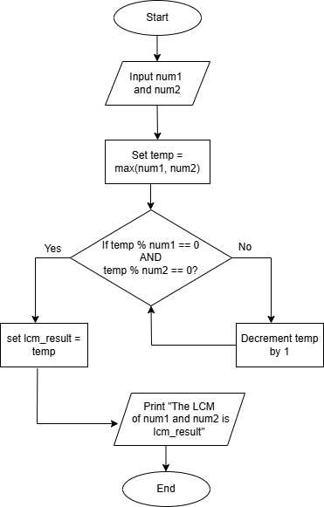

**SOURCE CODE:**

num1 = int(input("Enter num1: "))

num2 = int(input("Enter num2: "))

temp = max(num1, num2)

while True:

    if temp % num1 == 0 and temp % num2 == 0:

        lcm_result = temp

        break

    temp += 1

print(f"The LCM of {num1} and {num2} is {lcm_result}")

**OUTPUT:**

Enter num1: 15

Enter num2: 20

The LCM of 15 and 20 is 60

**RESULT:**

Thus the python program to print the LCM of the given number has been successfully executed and the output was verified.

|  |  |
| --- | --- |
| **EX:NO: 1.6** | **WRITE  CONDITIONAL AND LOOPING STATEMENTS IN PYTHON** |
| **DATE:** |
| **IMPLEMENTATION OF A PYTHON PROGRAM TO FIND THE FACTORIAL OF A NUMBER USING A WHILE LOOP** | |

**AIM:**

To write a Python program to find the factorial of a number using a while loop.

**PSEUDO CODE:**

START

    PROMPT user to enter a number and store it in num

    SET factorial to 1

    SET counter to 1

    WHILE counter is less than or equal to num:

        MULTIPLY factorial by counter

        INCREMENT counter by 1

    PRINT "The factorial of num is factorial."

END

**FLOW CHART:**

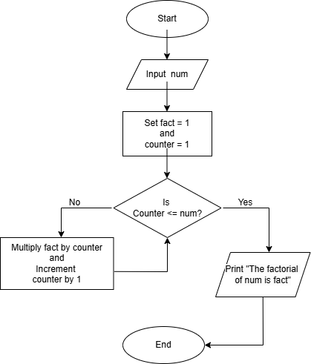

**SOURCE CODE:**

num = int(input("Enter a number: "))

factorial = 1

counter = 1

while counter <= num:

    factorial *= counter

    counter += 1

print(f"The factorial of {num} is {factorial}.")

**OUTPUT:**

Enter a number: 5

The factorial of 5 is 120.

**RESULT:**

Thus the python program to find the factorial of a number using a while loop has been successfully executed and the output was verified.

|  |  |
| --- | --- |
| **EX:NO: 1.7** | **WRITE  CONDITIONAL AND LOOPING STATEMENTS IN PYTHON** |
| **DATE:** |
| **IMPLEMENTATION OF PYTHON PROGRAM TO PRINT N FIBONACCI SERIES** | |

**AIM:**

To write a python program to print n Fibonacci series

**PSEUDO CODE:**

START

  START

    INPUT number 'n'

    SET a = 0

    SET b = 1

    PRINT a

    FOR i = 1 TO n-1:

        PRINT b

        SET a = b

        SET b = a + b

    END FOR

END

**FLOW CHART:**

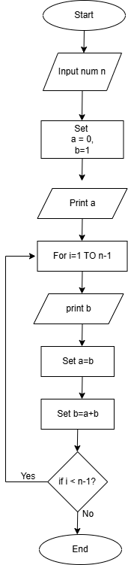

**SOURCE CODE:**

n = int(input("Enter the value of N: "))

a, b = 0, 1

print(a,end=’ ‘)

for i in range(1,n):

    print(b, end=" ")

a = b

b=a+b

**OUTPUT:**

Enter the value of N: 4

0 1 1 2

**RESULT:**

Thus the python program to print n Fibonacci series has been successfully executed and the output was verified.

|  |  |
| --- | --- |
| **EX:NO: 1.8** | **WRITE  CONDITIONAL AND LOOPING STATEMENTS IN PYTHON** |
| **DATE:** |
| **IMPLEMENTATION OF A PYTHON PROGRAM TO PRINT A PATTERN OF STARS (*) IN A RIGHT-ANGLED TRIANGLE SHAPE WITH 5 ROWS USING A LOOP.** | |

**AIM:**

To write a Python program to print a pattern of stars (*) in a right-angled triangle shape with 5 rows using a loop.

**PSEUDO CODE:**

START

    FOR i from 1 to 5 (inclusive):

        PRINT i number of "*" characters in a row

END

**SOURCE CODE:**

for i in range(1, 6):

    print("*" * i)

**OUTPUT:**

**\***

**\*\***

**\*\*\***

**\*\*\*\***

**\*\*\*\*\***

**RESULT:**

Thus the python program  to print a pattern of stars (*) in a right-angled triangle shape with 5 rows using a loop has been successfully executed and the output was verified.

|  |  |
| --- | --- |
| **EX:NO: 2.1** | **CREATE AND MANIPULATE STRINGS  USING INDEXING , SLICING AND VARIOUS STRING FUNCTIONS** |
| **DATE:** |
| **CREATE AND MANIPULATE STRINGS USING INDEXING, SLICING, AND VARIOUS STRING FUNCTIONS** | |

**AIM:**

To create and manipulate strings using indexing, slicing, and various string functions

**PSEUDO CODE:**

START

1. Initialize a string variable with the value "Hello, World!".

   Set my_string = "Hello, World!"

2. Indexing:

   - Access the first character of the string (index 0).

     PRINT the first character.

   - Access the last character of the string (index -1).

     PRINT the last character.

3. Slicing:

   - Extract the substring from index 7 to index 11 (inclusive).

     PRINT the substring.

4. Use string functions:

   - Calculate the length of the string using the length function.

     PRINT the length of the string.

   - Convert the string to uppercase and PRINT it.

   - Convert the string to lowercase and PRINT it.

END

**SOURCE CODE:**

my_string = "Hello, World!"

print("First character:", my_string[0])

print("Last character:", my_string[-1])

substring = my_string[7:12]

print("Substring (from index 7 to 11):", substring)

print("Length of the string:", len(my_string))

print("Uppercase string:", my_string.upper())

print("Lowercase string:", my_string.lower())

**OUTPUT:**

First character: H

Last character: !

Substring (from index 7 to 11): World

Length of the string: 13

Uppercase string: HELLO, WORLD!

Lowercase string: hello, world!

**RESULT:**

Thus the python program **to create and manipulate strings using indexing, slicing, and various string functions** has been successfully executed and the output was verified.

|  |  |
| --- | --- |
| **EX:NO: 2.2** | **CREATE AND MANIPULATE STRINGS  USING INDEXING , SLICING AND VARIOUS STRING FUNCTIONS** |
| **DATE:** |
| **IMPLEMENTATION OF PYTHON PROGRAM TO CHECK IF ONE STRING CONTAINS ANOTHER STRING.** | |

**AIM:**

To write a Python program to check if one string contains another string.

**PSEUDO CODE:**

START

    PROMPT the user to enter the main string and store it in input_string

    PROMPT the user to enter the substring to check and store it in substring

    IF substring is found in input_string:

        PRINT "The substring 'substring' is found in the string."

    ELSE:

        PRINT "The substring 'substring' is not found in the string."

END

**SOURCE CODE:**

input_string = input("Enter the main string: ")

substring = input("Enter the substring to check: ")

if input_string.find(substring)>=0:

    print(f"The substring '{substring}' is found in the string.")

else:

    print(f"The substring '{substring}' is not found in the string.")

**OUTPUT:**

Enter the main string: hello world

Enter the substring to check: world

The substring 'world' is found in the string.

**RESULT:**

Thus the **Python program to check if one string contains another string** has been successfully executed and the output was verified.

|  |  |
| --- | --- |
| **EX:NO: 2.3** | **CREATE AND MANIPULATE STRINGS  USING INDEXING , SLICING AND VARIOUS STRING FUNCTIONS** |
| **DATE:** |
| **IMPLEMENTATION OF PYTHON PROGRAM TO CHECK IF ALL CHARACTERS IN A STRING ARE DIGITS** | |

**AIM:**

To write a Python program to Check if All Characters in a String Are Digits

**PSEUDO CODE:**

START

    PROMPT the user to enter a string and store it in input_string

    IF input_string contains only digits:

        PRINT "The string 'input_string' contains only digits."

    ELSE:

        PRINT "The string 'input_string' does not contain only digits."

END

**SOURCE CODE:**

input_string = input("Enter a string: ")

if input_string.isdigit():

    print(f"The string '{input_string}' contains only digits.")

else:

    print(f"The string '{input_string}' does not contain only digits.")

**OUTPUT:**

Enter a string: 123

The string '123' contains only digits.

**RESULT:**

Thus the Python program to Remove Duplicates from a String has been successfully executed and the output was verified.

|  |  |
| --- | --- |
| **EX:NO: 2.4** | **CREATE AND MANIPULATE STRINGS  USING INDEXING , SLICING AND VARIOUS STRING FUNCTIONS** |
| **DATE:** |
| **IMPLEMENTATION OF PYTHON PROGRAM TO REMOVE ALL VOWELS FROM THE STRING** | |

**AIM:**

To write a Python program to remove all vowels from the string

**PSEUDO CODE:**

START

    PROMPT the user to enter a string and store it in input_string

    SET vowels to the string "aeiouAEIOU" (all vowels in both lowercase and uppercase)

    CREATE an empty string result

    FOR each character in input_string:

        IF the character is NOT in vowels:

            ADD the character to result

    PRINT the message: "String after removing vowels: result"

END

**SOURCE CODE:**

input_string = input("Enter a string: ")

vowels = "aeiouAEIOU"

result = ''.join([char for char in input_string if char not in vowels])

print(f"String after removing vowels: {result}")

**OUTPUT:**

Enter a string: hello world

String after removing vowels: hll wrld

**RESULT:**

Thus the python program to remove all vowels from the string  has been successfully executed and the output was verified.

|  |  |
| --- | --- |
| **EX:NO: 2.5** | **CREATE AND MANIPULATE STRINGS  USING INDEXING , SLICING AND VARIOUS STRING FUNCTIONS** |
| **DATE:** |
| **IMPLEMENTATION OF PYTHON PROGRAM TO COUNT OCCURRENCES OF A CHARACTER IN A STRING** | |

**AIM:**

To write a Python program to count occurrences of a character in a String

**PSEUDO CODE:**

START

    PROMPT the user to enter a string and store it in input_string

    PROMPT the user to enter the character to count and store it in char

    CALL the count() function on input_string to count the occurrences of char

    STORE the result in variable count

    PRINT the message: "The character 'char' appears 'count' times in the string."

END

**SOURCE CODE:**

input_string = input("Enter a string: ")

char = input("Enter the character to count: ")

count = input_string.count(char)

print(f"The character '{char}' appears {count} times in the string.")

**OUTPUT:**

Enter a string: hello world

Enter the character to count: o

The character 'o' appears 2 times in the string.

**RESULT:**

Thus the python program to count occurrences of a character in a String has been successfully executed and the output was verified.

|  |  |
| --- | --- |
| **EX:NO: 3.1** | **CREATE AND MANIPULATE LISTS USING OPERATIONS , SLICES, METHODS , LIST COMPREHENSION AND  LOOPING** |
| **DATE:** |
| **CREATE AND MANIPULATE LISTS USING OPERATIONS , SLICES, METHODS , LIST COMPREHENSION AND  LOOPING** | |

**AIM:**

To create and manipulate lists using operations, slices, methods, list comprehension, and looping.

**PSEUDO CODE:**

START

1. Initialize a list called "numbers" with elements [5, 10, 15, 20, 25, 30].

2. Add the number 35 to the end of the list.

   PRINT the updated list.

3. Remove the number 15 from the list.

   PRINT the updated list.

4. Modify the element at index 2 of the list to be 100.

   PRINT the updated list.

5. Extract a sublist from index 1 to index 4 (inclusive).

   PRINT the sublist.

6. Create a new list containing all numbers greater than 20 from the "numbers" list using list comprehension.

   PRINT the new list.

7. Loop through each number in the "numbers" list and print the number multiplied by 2.

8. Check if the number 25 exists in the list.

   IF 25 is in the list:

      PRINT "25 is in the list."

   ELSE:

      PRINT "25 is not in the list."

END

**SOURCE CODE:**

numbers = [5, 10, 15, 20, 25, 30]

numbers.append(35)

print("List after appending 35:", numbers)

numbers.remove(15)

print("List after removing 15:", numbers)

numbers[2] = 100

print("List after modifying the element at index 2:", numbers)

sublist = numbers[1:5]

print("Sliced list from index 1 to 4:", sublist)

greater_than_20 = [num for num in numbers if num > 20]

print("List of numbers greater than 20:", greater_than_20)

print("Each number doubled:")

for num in numbers:

    print(num * 2)

if 25 in numbers:

    print("25 is in the list.")

else:

    print("25 is not in the list.")

**OUTPUT:**

List after appending 35: [5, 10, 15, 20, 25, 30, 35]

List after removing 15: [5, 10, 20, 25, 30, 35]

List after modifying the element at index 2: [5, 10, 100, 25, 30, 35]

Sliced list from index 1 to 4: [10, 100, 25, 30]

List of numbers greater than 20: [100, 25, 30, 35]

Each number doubled:

10

20

200

50

60

70

25 is in the list.

**RESULT:**

Thus the python program  to create and manipulate lists using operations, slices, methods, list comprehension, and looping  has been successfully executed and the output was verified.

|  |  |
| --- | --- |
| **EX:NO: 3.2** | **CREATE AND MANIPULATE LISTS USING OPERATIONS , SLICES, METHODS , LIST COMPREHENSION AND  LOOPING** |
| **DATE:** |
| **IMPLEMENTATION OF PYTHON PROGRAM TO SEARCH AN ELEMENT FROM THE GIVEN LIST USING LINEAR SEARCH.** | |

**AIM:**

To write a Python program to search an element from the given list using Linear search.

**PSEUDO CODE:**

START

    PROMPT user to input a list of numbers separated by space

    CONVERT the input string to a list of integers and store it in arr

    PROMPT user to input the number to search for, store it in target

    SET found to False

    FOR each index i from 0 to length of arr - 1:

        IF arr[i] equals target:

            SET found to True

            PRINT "Number target found at index i"

            BREAK the loop

    IF found is False:

        PRINT "Number target not found in the list."

END

**SOURCE CODE:**

arr = list(map(int, input("Enter a list of numbers separated by space: ").split()))

target = int(input("Enter the number you want to search for: "))

found = False

for i in range(len(arr)):

    if arr[i] == target:

        found = True

        print(f"Number {target} found at index {i}")

        break

if not found:

    print(f"Number {target} not found in the list.")

**OUTPUT:**

Enter a list of numbers separated by space: 2 5 8 9 10

Enter the number you want to search for: 5

Number 5 found at index 1

**RESULT:**

Thus the python programto search an element from the given list using Linear search has been successfully executed and the output was verified.

|  |  |
| --- | --- |
| **EX:NO: 3.3** | **CREATE AND MANIPULATE LISTS USING OPERATIONS , SLICES, METHODS , LIST COMPREHENSION AND  LOOPING** |
| **DATE:** |
| **IMPLEMENTATION OF PYTHON PROGRAM TO SEARCH AN ELEMENT FROM THE GIVEN LIST USING BINARY SEARCH.** | |

**AIM:**

To write a Python program to search an element from the given list using Binary search.

**PSEUDO CODE:**

START

    PROMPT user to input a list of numbers separated by space

    CONVERT the input string to a list of integers and store it in arr

    PROMPT user to input the number to search for, store it in target

    SET found to False

    SET low to 0 and high to len-1

    WHILE low <=high:

       CALCULATE mid = (low+high)//2

        IF arr[mid] equals target:

            SET found to True

            PRINT "Number target found at index i"

            BREAK the loop

      ELSE IF arr[mid] is less than target:

           SET low to mid+1

     ELSE:

          SET high to mid-1

    IF found is False:

        PRINT "Number target not found in the list."

END

**SOURCE CODE:**

arr = list(map(int, input("Enter a list of numbers separated by space (sorted): ").split()))

target = int(input("Enter the number you want to search for: "))

low = 0

high = len(arr) - 1

found = False

while low <= high:

    mid = (low + high) // 2

    if arr[mid] == target:

        found = True

        print(f"Number {target} found at index {mid}")

        break

    elif arr[mid] < target:

        low = mid + 1  # Search the right half

    else:

        high = mid - 1  # Search the left half

if not found:

    print(f"Number {target} not found in the list.")

**OUTPUT:**

Enter a list of numbers separated by space (sorted): 2 5 8 9 10

Enter the number you want to search for: 5

Number 5 found at index 1

**RESULT:**

Thus the python programto search an element from the given list using Binary search has been successfully executed and the output was verified.

|  |  |
| --- | --- |
| **EX:NO: 3.4** | **CREATE AND MANIPULATE LISTS USING OPERATIONS , SLICES, METHODS , LIST COMPREHENSION AND  LOOPING** |
| **DATE:** |
| **IMPLEMENTATION OF PYTHON PROGRAM SUM ALL THE NUMBERS IN THE GIVEN LIST** | |

**AIM:**

To write a Python program to sum all the numbers in the given list

**PSEUDO CODE:**

START

    PROMPT the user to enter a list of numbers and store it in a list called numbers

    SET total_sum = 0

    FOR each num in numbers:

        ADD num to total_sum

    PRINT total_sum

END

**SOURCE CODE:**

numbers = list(map(int, input("Enter a list of numbers separated by space: ").split()))

total_sum = 0

for num in numbers:

    total_sum += num

print("The sum of all numbers in the list is:", total_sum)

**OUTPUT:**

Enter a list of numbers separated by space: 1 8 4 2 6 10

The sum of all numbers in the list is: 31

**RESULT:**

Thus the python programto sum all the numbers in the given list has been successfully executed and the output was verified.

|  |  |
| --- | --- |
| **EX:NO: 3.5** | **CREATE AND MANIPULATE LISTS USING OPERATIONS , SLICES, METHODS , LIST COMPREHENSION AND  LOOPING** |
| **DATE:** |
| **IMPLEMENTATION OF PYTHON PROGRAM TO SORT THE ELEMENTS IN THE LIST USING BUBBLE SORT** | |

**AIM:**

To write a Python program to sort the elements in the list using Bubble sort

**PSEUDO CODE:**

START

    PROMPT the user to enter a list of numbers and store it in a list called numbers

    SET n = length of numbers

    FOR i from 0 to n-1:

        FOR j from 0 to n-i-2:

            IF numbers[j] > numbers[j+1]:

                SWAP numbers[j] and numbers[j+1]

    PRINT numbers

END

**SOURCE CODE:**

numbers = list(map(int, input("Enter a list of numbers separated by space: ").split()))

n = len(numbers)

for i in range(n):

    for j in range(0, n-i-1):

        if numbers[j] > numbers[j+1]:

            numbers[j], numbers[j+1] = numbers[j+1], numbers[j]

print("Sorted list:", numbers)

**OUTPUT:**

Enter a list of numbers separated by space: 4 2 8 1 4 7 4 0

Sorted list: [0, 1, 2, 4, 4, 4, 7, 8]

**RESULT:**

Thus the python programto sort the elements in the list using Bubble sort has been successfully executed and the output was verified.

|  |  |
| --- | --- |
| **EX:NO: 4.1** | **CREATE AND MANIPULATE TUPLES, DICTIONARIES, AND SETS, AND UNDERSTAND THE DIFFERENCES BETWEEN MUTABLE AND IMMUTABLE TYPES.** |
| **DATE:** |
| **IMPLEMENTATION OF A PYTHON PROGRAM TO CREATE AND MANIPULATE TUPLES.** | |

**AIM:**

To write a python program to create and manipulate tuples.

**PSEUDO CODE:**

START

Create a tuple of 'fruits' with the values: ("apple", "banana", "cherry", "orange", "mango").

Print the original 'fruits' tuple.

Access and print the first element of 'fruits'.

Access and print the last element of 'fruits'.

Slice the 'fruits' tuple from index 1 to index 4 (excluding 4), and print the sliced tuple.

Create another tuple 'veggies' with values: ("carrot", "broccoli", "spinach").

Concatenate 'fruits' and 'veggies' and store the result in 'all_food'. Print 'all_food'.

Repeat the 'fruits' tuple two times and store the result in 'repeat_fruits'. Print 'repeat_fruits'.

Check if "banana" exists in 'fruits'. Print the result ("True" or "False").

Check if "grape" exists in 'fruits'. Print the result ("True" or "False").

Calculate the length of the 'fruits' tuple and print the result.

END

**SOURCE CODE:**

fruits = ("apple", "banana", "cherry", "orange", "mango")

print("Original Tuple:", fruits)

print("\nFirst element:", fruits[0])

print("Last element:", fruits[-1])

print("\nSliced Tuple (2nd to 4th elements):", fruits[1:4])

veggies = ("carrot", "broccoli", "spinach")

all_food = fruits + veggies

print("\nConcatenated Tuple (Fruits + Veggies):", all_food)

repeat_fruits = fruits * 2

print("\nRepeated Tuple:", repeat_fruits)

print("\nIs 'banana' in the fruits tuple?", "banana" in fruits)

print("Is 'grape' in the fruits tuple?", "grape" in fruits)

print("\nLength of the tuple:", len(fruits))

**OUTPUT:**

Original Tuple: ('apple', 'banana', 'cherry', 'orange', 'mango')

First element: apple

Last element: mango

Sliced Tuple (2nd to 4th elements): ('banana', 'cherry', 'orange')

Concatenated Tuple (Fruits + Veggies): ('apple', 'banana', 'cherry', 'orange', 'mango', 'carrot', 'broccoli', 'spinach')

Repeated Tuple: ('apple', 'banana', 'cherry', 'orange', 'mango', 'apple', 'banana', 'cherry', 'orange', 'mango')

Is 'banana' in the fruits tuple? True

Is 'grape' in the fruits tuple? False

Length of the tuple: 5

**RESULT:**

Thus the python programto create and manipulate tuples has been successfully executed and the output was verified.

|  |  |
| --- | --- |
| **EX:NO: 4.2** | **CREATE AND MANIPULATE TUPLES, DICTIONARIES, AND SETS, AND UNDERSTAND THE DIFFERENCES BETWEEN MUTABLE AND IMMUTABLE TYPES.** |
| **DATE:** |
| **IMPLEMENTATION OF PYTHON PROGRAM TO CREATE AND MANIPULATE DICTIONARIES.** | |

**AIM:**

To write a python program to create and manipulate dictionaries.

**PSEUDO CODE:**

START

Create a dictionary called "student" with keys "name", "age", and "subjects" and their corresponding values.

Print the original "student" dictionary.

Access the value associated with the key "name" and print it.

Add a new key-value pair "grade" with the value "A" to the "student" dictionary.

Print the updated dictionary after adding the "grade".

Modify the value of the key "age" to 21.

Print the updated dictionary after modifying the "age".

Remove the key-value pair for "subjects" from the "student" dictionary using the `pop` method.

Print the updated dictionary after removing "subjects".

Check if the key "grade" exists in the dictionary.

    - If it exists, print the value associated with the key "grade".

Iterate over the "student" dictionary.

    - For each key-value pair in the dictionary, print the key and its corresponding value.

END

**SOURCE CODE:**

student = {

    "name": "Alice",

    "age": 20,

    "subjects": ["Math", "Science"]

}

print("Original Dictionary:", student)

print("\nName:", student["name"])

student["grade"] = "A"

print("\nAfter adding grade:", student)

student.update({"age": 21})

print("\nAfter modifying age:", student)

student.pop("subjects")

print("\nAfter removing subjects:", student)

print("\nIterating through the dictionary:")

for key, value in student.items():

    print(f"{key}: {value}")

**OUTPUT:**

Original Dictionary: {'name': 'Alice', 'age': 20, 'subjects': ['Math', 'Science']}

Name: Alice

After adding grade: {'name': 'Alice', 'age': 20, 'subjects': ['Math', 'Science'], 'grade': 'A'}

After modifying age: {'name': 'Alice', 'age': 21, 'subjects': ['Math', 'Science'], 'grade': 'A'}

After removing subjects: {'name': 'Alice', 'age': 21, 'grade': 'A'}

Iterating through the dictionary:

name: Alice

age: 21

grade: A

**RESULT:**

Thus the python programto create and manipulate dictionaries has been successfully executed and the output was verified.

|  |  |
| --- | --- |
| **EX:NO: 4.3** | **CREATE AND MANIPULATE TUPLES, DICTIONARIES, AND SETS, AND UNDERSTAND THE DIFFERENCES BETWEEN MUTABLE AND IMMUTABLE TYPES.** |
| **DATE:** |
| **IMPLEMENTATION OF PYTHON PROGRAM TO CREATE AND MANIPULATE SETS**. | |

**AIM:**

To write a python program to create and manipulate sets.

**PSEUDO CODE:**

START

    CREATE a set "fruits" with elements: "apple", "banana", "cherry", "orange", "mango"

    PRINT "Original Set" with "fruits"

    ADD "grapes" to "fruits"

    PRINT "After adding grapes" with "fruits"

    REMOVE "banana" from "fruits"

    PRINT "After removing banana" with "fruits"

    CHECK if "apple" is in "fruits"

    PRINT result for checking if "apple" exists in "fruits"

    CHECK if "pear" is in "fruits"

    PRINT result for checking if "pear" exists in "fruits"

    CREATE a set "vegetables" with elements: "carrot", "broccoli", "spinach"

    UNION "fruits" and "vegetables" into "all_food"

    PRINT "Union of fruits and vegetables" with "all_food"

    INTERSECTION of "fruits" and "vegetables" into "common_food"

    PRINT "Common food in fruits and vegetables" with "common_food"

    POP an arbitrary element from "fruits" into "removed_element"

    PRINT "Removed an arbitrary element" with "removed_element"

    PRINT "Set after popping an element" with "fruits"

    CLEAR "fruits"

    PRINT "Set after clearing all elements" with "fruits"

END

**SOURCE CODE:**

fruits = {"apple", "banana", "cherry", "orange", "mango"}

print("Original Set:", fruits)

fruits.add("grapes")

print("\nAfter adding grapes:", fruits)

fruits.remove("banana")

print("\nAfter removing banana:", fruits)

print("\nIs 'apple' in the set?", "apple" in fruits)

print("Is 'pear' in the set?", "pear" in fruits)

vegetables = {"carrot", "broccoli", "spinach"}

all_food = fruits.union(vegetables)

print("\nUnion of fruits and vegetables:", all_food)

common_food = fruits.intersection(vegetables)

print("\nCommon food in fruits and vegetables:", common_food)

removed_element = fruits.pop()

print("\nRemoved an arbitrary element:", removed_element)

print("Set after popping an element:", fruits)

fruits.clear()

print("\nSet after clearing all elements:", fruits)

**OUTPUT:**

Original Set: {'orange', 'banana', 'mango', 'apple', 'cherry'}

After adding grapes: {'grapes', 'orange', 'banana', 'mango', 'apple', 'cherry'}

After removing banana: {'grapes', 'orange', 'mango', 'apple', 'cherry'}

Is 'apple' in the set? True

Is 'pear' in the set? False

Union of fruits and vegetables: {'spinach', 'grapes', 'orange', 'carrot', 'mango', 'apple', 'cherry', 'broccoli'}

Common food in fruits and vegetables: set()

Removed an arbitrary element: grapes

Set after popping an element: {'orange', 'mango', 'apple', 'cherry'}

Set after clearing all elements: set()

**RESULT:**

Thus the python programto create and manipulate sets has been successfully executed and the output was verified.

|  |  |
| --- | --- |
| **EX:NO: 4.4** | **CREATE AND MANIPULATE TUPLES, DICTIONARIES, AND SETS, AND UNDERSTAND THE DIFFERENCES BETWEEN MUTABLE AND IMMUTABLE TYPES.** |
| **DATE:** |
| **ILLUSTRATE THE DIFFERENCES BETWEEN MUTABLE AND IMMUTABLE TYPES.** | |

**AIM:**

To write a Python program to Illustrate the differences between mutable and immutable types.

**PSEUDO CODE:**

START

1. Define an immutable object (String):

   - Set `str_example` to "Hello"

   - Print the original string

   - Modify the string by creating a new string: "h" + the substring of `str_example` starting from the second character

   - Print the modified string

2. Define a mutable object (List):

   - Set `list_example` to [1, 2, 3]

   - Print the original list

   - Modify the first element of the list to 10

   - Print the modified list

   - Append 4 to the list

   - Print the list after adding an element

   - Remove element 2 from the list

   - Print the list after removing an element

3. Demonstrate the modification of a mutable object (List):

   - Set `mutable_list` to [1, 2, 3]

   - Print the original mutable list

   - Append 100 to the list

   - Print the modified mutable list

4. Demonstrate the modification of an immutable object (String):

   - Set `immutable_str` to "Hello"

   - Print the original immutable string

   - Modify the string by concatenating " World!" to `immutable_str` and assign it to a new string

   - Print the modified immutable string

END

**SOURCE CODE:**

str_example = "Hello"

print("Original String:", str_example)

str_example = "h" + str_example[1:]

print("\nModified String (New String Created):", str_example)

list_example = [1, 2, 3]

print("\nOriginal List:", list_example)

list_example[0] = 10

print("\nModified List:", list_example)

list_example.append(4)

print("\nList after adding an element:", list_example)

list_example.remove(2)

print("\nList after removing an element:", list_example)

mutable_list = [1, 2, 3]

print("\nBefore modifying the mutable list:", mutable_list)

mutable_list.append(100)

print("After modifying the mutable list:", mutable_list)

immutable_str = "Hello"

print("\nBefore modifying the immutable string:", immutable_str)

immutable_str = immutable_str + " World!"

print("After modifying the immutable string:", immutable_str)

**OUTPUT:**

Original String: Hello

Modified String (New String Created): hello

Original List: [1, 2, 3]

Modified List: [10, 2, 3]

List after adding an element: [10, 2, 3, 4]

List after removing an element: [10, 3, 4]

Before modifying the mutable list: [1, 2, 3]

After modifying the mutable list: [1, 2, 3, 100]

Before modifying the immutable string: Hello

After modifying the immutable string: Hello World!

**RESULT:**

Thus the python program to Illustrate the differences between mutable and immutable types has been successfully executed and the output was verified.

|  |  |
| --- | --- |
| **EX:NO: 5.1** | **IMPLEMENT USER-DEFINED FUNCTIONS AND UNDERSTAND THE DIFFERENT TYPES OF FUNCTION ARGUMENTS, SUCH AS POSITIONAL, KEYWORD, AND DEFAULT ARGUMENTS.** |
| **DATE:** |
| **IMPLEMENT USER-DEFINED FUNCTIONS AND UNDERSTAND THE DIFFERENT TYPES OF FUNCTION ARGUMENTS, SUCH AS POSITIONAL, KEYWORD, AND DEFAULT ARGUMENTS.** | |

**AIM:**

To implement user-defined functions and understand the different types of function arguments, such as positional, keyword, and default arguments.

**PSEUDO CODE:**

START

Define a function "add_numbers" that takes two parameters (a, b) and returns their sum.

Define a function "greet" that takes two parameters (name, age) and prints a greeting message.

Define a function "introduce" that takes two parameters (name, age) where 'age' has a default value of 30. It prints a message introducing the person.

Call the "add_numbers" function with 10 and 20 as arguments and store the result in "result".

   PRINT the result.

Call the "greet" function with "Alice" and 25 as keyword arguments.

Call the "introduce" function with "Bob" as the only argument. Use the default value for age.

Call the "introduce" function with "Charlie" and 40 as arguments to override the default age.

END

**SOURCE CODE:**

def add_numbers(a, b):

    return a + b

def greet(name, age):

    print(f"Hello, {name}! You are {age} years old.")

def introduce(name, age=30):

    print(f"My name is {name} and I am {age} years old.")

result = add_numbers(10, 20)

print("Sum using positional arguments:", result)

greet(name="Alice", age=25)

introduce(name="Bob")

introduce(name="Charlie", age=40)

**OUTPUT:**

Sum using positional arguments: 30

Hello, Alice! You are 25 years old.

My name is Bob and I am 30 years old.

My name is Charlie and I am 40 years old.

**RESULT:**

Thus the python program to implement user-defined functions and understand the different types of function arguments, such as positional, keyword, and default arguments has been successfully executed and the output was verified.

|  |  |
| --- | --- |
| **EX:NO: 6.1** | **IIMPLEMENT INHERITANCE AND UNDERSTAND THE DIFFERENT TYPES OF INHERITANCE.** |
| **DATE:** |
| **IMPLEMENT A PYTHON PROGRAM TO ILLUSTRATE SINGLE INHERITANCE** | |

**AIM:**

To write a python program to illustrate Single inheritance

**PSEUDO CODE:**

START

1. Define Parent Class `Person`:

    - Define `__init__` method:

        - Initialize attributes `name` and `age` with provided values.

    - Define `display` method:

        - Print the values of `name` and `age`.

2. Define Child Class `Student` that inherits from `Person`:

    - Define `__init__` method:

        - Call the parent class's `__init__` method to initialize `name` and `age`.

        - Initialize attribute `grade` with provided value.

    - Define `display_student_info` method:

        - Call the `display` method from the parent class to print `name` and `age`.

        - Print the value of `grade`.

3. In Main Program:

    - Create an instance of `Student` with `name` as "Alice", `age` as 20, and `grade` as "A".

    - Call the `display_student_info` method of the `student1` instance to display all information (name, age, grade).

END

**SOURCE CODE:**

class Person:

    def __init__(self, name, age):

        self.name = name

        self.age = age

    def display(self):

        print(f"Name: {self.name}")

        print(f"Age: {self.age}")

class Student(Person):

    def __init__(self, name, age, grade):

        super().__init__(name, age)

        self.grade = grade

    def display_student_info(self):

        self.display()

        print(f"Grade: {self.grade}")

student1 = Student("Alice", 20, "A")

student1.display_student_info()

**OUTPUT:**

Name: Alice

Age: 20

Grade: A

**RESULT:**

Thus the python program to illustrate Single level inheritance has been successfully executed and the output was verified.

|  |  |
| --- | --- |
| **EX:NO: 6.2** | **IIMPLEMENT INHERITANCE AND UNDERSTAND THE DIFFERENT TYPES OF INHERITANCE.** |
| **DATE:** |
| **IMPLEMENT PYTHON PROGRAM TO ILLUSTRATE MULTI-LEVEL INHERITANCE** | |

**AIM:**

To write a python program to illustrate multi-level inheritance

**PSEUDO CODE:**

START

1. Define the Grandparent class "Animal":

    - Initialize a variable "species" in the constructor.

    - Define a method "display_species" that prints the species.

2. Define the Parent class "Mammal" that inherits from "Animal":

    - Initialize variables "species" and "habitat" in the constructor.

    - Call the parent class constructor using `super()` to initialize "species".

    - Define a method "display_habitat" that prints the habitat.

3. Define the Child class "Dog" that inherits from "Mammal":

    - Initialize variables "species", "habitat", and "breed" in the constructor.

    - Call the parent class constructor using `super()` to initialize "species" and "habitat".

    - Define a method "display_breed" that prints the breed.

4. In the main program:

    - Create an instance of the "Dog" class with specific "species", "habitat", and "breed".

    - Call the "display_species" method from "Animal".

    - Call the "display_habitat" method from "Mammal".

    - Call the "display_breed" method from "Dog".

END

**SOURCE CODE:**

class Animal:

    def __init__(self, species):

        self.species = species

    def display_species(self):

        print(f"Species: {self.species}")

class Mammal(Animal):

    def __init__(self, species, habitat):

        super().__init__(species)

        self.habitat = habitat

    def display_habitat(self):

        print(f"Habitat: {self.habitat}")

class Dog(Mammal):

    def __init__(self, species, habitat, breed):

        super().__init__(species, habitat)

        self.breed = breed

    def display_breed(self):

        print(f"Breed: {self.breed}")

dog1 = Dog("Dog", "Domestic", "Golden Retriever")

dog1.display_species()

dog1.display_habitat()

dog1.display_breed()

**OUTPUT:**

Species: Dog

Habitat: Domestic

Breed: Golden Retriever

**RESULT:**

Thus the python program to illustrate  Multi-level inheritance has been successfully executed and the output was verified.

|  |  |
| --- | --- |
| **EX:NO: 6.3** | **IIMPLEMENT INHERITANCE AND UNDERSTAND THE DIFFERENT TYPES OF INHERITANCE.** |
| **DATE:** |
| **IMPLEMENT A PYTHON PROGRAM TO ILLUSTRATE MULTIPLE INHERITANCE** | |

**AIM:**

To write a python program to illustrate multiple inheritance

**PSEUDO CODE:**

START

Define Class Person:

Constructor:

Input: name

Set self.name = name

Method get_name:

Return self.name

Define Class Worker:

Constructor:

Input: job_title

Set self.job_title = job_title

Method get_job:

Return self.job_title

Define Class Manager (Inherits from Person and Worker):

Constructor:

Input: name, job_title, department

Call Person constructor with name

Call Worker constructor with job_title

Set self.department = department

Method get_department:

Return self.department

Create Instance of Manager:

Input: "Alice", "Software Engineer", "IT"

Assign to variable manager

Call Methods on manager Object:

Call get_name:

Output: "Alice"

Call get_job:

Output: "Software Engineer"

Call get_department:

Output: "IT"

END

**SOURCE CODE:**

class Person:

    def __init__(self, name):

        self.name = name

    def get_name(self):

        return self.name

class Worker:

    def __init__(self, job_title):

        self.job_title = job_title

    def get_job(self):

        return self.job_title

class Manager(Person, Worker):  # Inherits from both Person and Worker

    def __init__(self, name, job_title, department):

        Person.__init__(self, name)

        Worker.__init__(self, job_title)

        self.department = department

    def get_department(self):

        return self.department

manager = Manager("Alice", "Software Engineer", "IT")

print(manager.get_name())

print(manager.get_job())

print(manager.get_department())

**OUTPUT:**

Alice

Software Engineer

IT

**RESULT:**

Thus the python program to illustrate multiple inheritance has been successfully executed and the output was verified.

|  |  |
| --- | --- |
| **EX:NO: 7.1** | **IMPLEMENT POLYMORPHISM THROUGH METHOD OVERLOADING, OVERRIDING, AND OPERATOR OVERLOADING.** |
| **DATE:** |
| **IMPLEMENT POLYMORPHISM THROUGH METHOD OVERLOADING BY PROVIDING DIFFERENT LOGIC FOR DIFFERENT INPUT** | |

**AIM:**

To implement polymorphism through method overloading by writing  the method’s logic so that different code executes inside the function depending on the parameter passed.

**PSEUDO CODE:**

START

Create Shape class

Define a method area

create Square object and call the area method

create rectangle object and call the area method

END

**SOURCE CODE**

class Shape:

    # function with two default parameters

    def area(self, a, b=0):

        if b > 0:

            print('Area of Rectangle is:', a * b)

        else:

            print('Area of Square is:', a ** 2)

square = Shape()

square.area(5) # if no.of arg is 1 then it is square

rectangle = Shape()

rectangle.area(5, 3) # if  no.of arg is 2 then it is rectangle

**OUTPUT:**

Area of Square is:25

Area of Rectangle is:15

**RESULT :**

Thus the python program for method overloading has been successfully executed and the output was verified.

|  |  |
| --- | --- |
| **EX:NO: 7.2** | **IMPLEMENT POLYMORPHISM THROUGH METHOD OVERLOADING, OVERRIDING, AND OPERATOR OVERLOADING.** |
| **DATE:** |
| **IMPLEMENT A PYTHON PROGRAM TO IMPLEMENT METHOD OVERRIDING** | |

**AIM:**

To write a python program to implement method overriding

**PSEUDO CODE:**

**START**

      Define a class "Animal":

  - Define a method "sound" that prints "Animal makes a sound".

     Define a class "Dog" that inherits from "Animal":

     - Override the "sound" method to print "Dog barks".

Create an object "animal" from the "Animal" class:

    - Call the "sound" method on "animal".

Create an object "dog" from the "Dog" class:

- Call the "sound" method on "dog".

END

**SOURCE CODE**

class Animal:

    def sound(self):

        print("Animal makes a sound")

class Dog(Animal):

    def sound(self):

        print("Dog barks")

animal = Animal()

animal.sound()

dog = Dog()

dog.sound()

**OUTPUT**

Animal makes a sound

Dog barks

**RESULT:**

Thus the python program for method overriding has been successfully executed and the output was verified.

|  |  |
| --- | --- |
| **EX:NO: 7.3** | **IMPLEMENT POLYMORPHISM THROUGH METHOD OVERLOADING, OVERRIDING, AND OPERATOR OVERLOADING.** |
| **DATE:** |
| **IMPLEMENT A PYTHON PROGRAM TO IMPLEMENT OPERATOR OVERLOADING** | |

**AIM:**

To write a python program to implement operator overloading

**PSEUDO CODE:**

START

 Define a class "ComplexNumber":

    - Define an initializer method that takes two parameters: "real" and "imag".

    - Define the "_add_" method to add two complex numbers by adding their real and imaginary parts.

    - Define the "_str_" method to represent the complex number as a string in the form "real + imag i".

 Create two objects "c1" and "c2" from the "ComplexNumber" class with real and imaginary parts:

    - Add "c1" and "c2" using the overloaded "+" operator and store the result in "c3".

    - Print the result of adding the complex numbers.

END

**SOURCE CODE**

class ComplexNumber:

    def __init__(self, real, imag):

        self.real = real

        self.imag = imag

    def __add__(self, other):

        return ComplexNumber(self.real + other.real, self.imag + other.imag)

    def __str__(self):

        return f"{self.real} + {self.imag}i"

c1 = ComplexNumber(3, 2)

c2 = ComplexNumber(1, 7)

c3 = c1 + c2

print("Sum of complex numbers:", c3)

**OUTPUT:**

Sum of complex numbers: 4 + 9i

**RESULT:**

Thus the python program for operator overloading has been successfully executed and the output was verified.